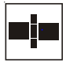
KULOVÝ KOHOUT S PLNÝM PRŮTOKEM
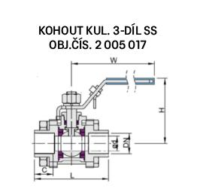
_________________________________________________
DN | d | L | H | W | C
15 | 15 | 67 | 59 | 105 | 18
20 | 20 | 77 | 65 | 125 | 25
25 | 25 | 87 | 67 | 125 | 21
32 | 32 | 96 | 80 | 150 | 21
40 | 38 | 112 | 90 | 155 | 21
50 | 48 | 139 | 99 | 155 | 35
65 | 65 | 168 | 145 | 250 | 44
80 | 78 | 200 | 135 | 230 | 44

