
MATICE

DN | D10 | M | N | T | Rd x S
10 | 38 | 18 | 6 | 2,5 | 28 x 1/8"
15 | 44 | 18 | 7 | 2,5 | 34 x 1/8"
20 | 54 | 21 | 7 | 3 | 44 x 1/6"
25 | 63 | 21 | 8 | 3,5 | 52 x 1/6"
32 | 70 | 21 | 8 | 4 | 58 x 1/6"
40 | 78 | 21 | 10 | 4 | 65 x 1/6"
50 | 92 | 22 | 10 | 4 | 78 x 1/6"
65 | 112 | 25 | 10 | 5 | 95 x 1/6"
80 | 127 | 30 | 10 | 5 | 110 x 1/4"
100 | 148 | 31 | 12 | 5 | 130 x 1/4"

ZASLEPOVACÍ MATICE

OBJ. ČÍS. 2 005 341
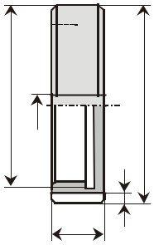

Rdxs | N | D10
 |  | T
 |  | M

